* **The website was tested using Testing Whiz.**

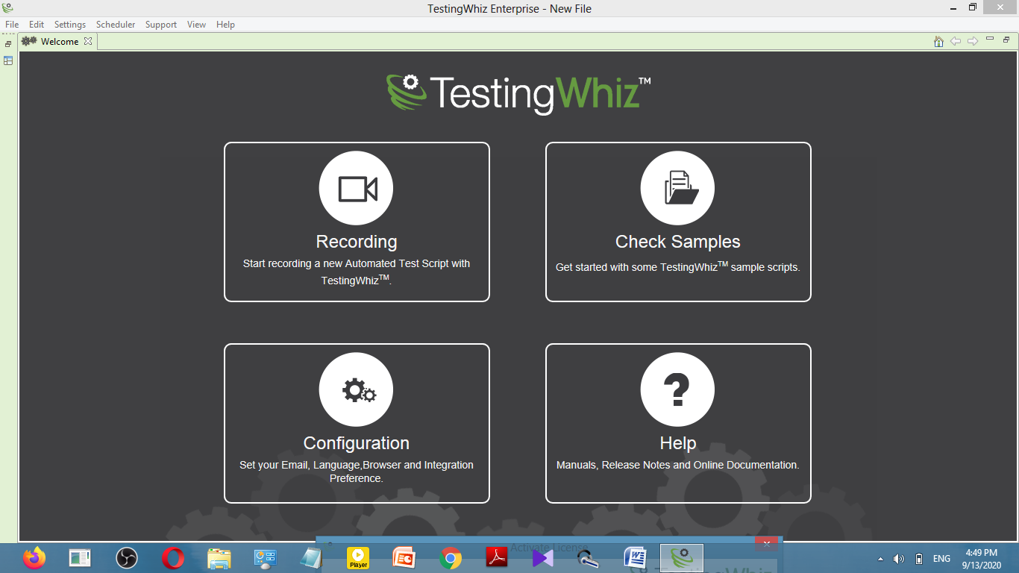

* **The academics page was created.**

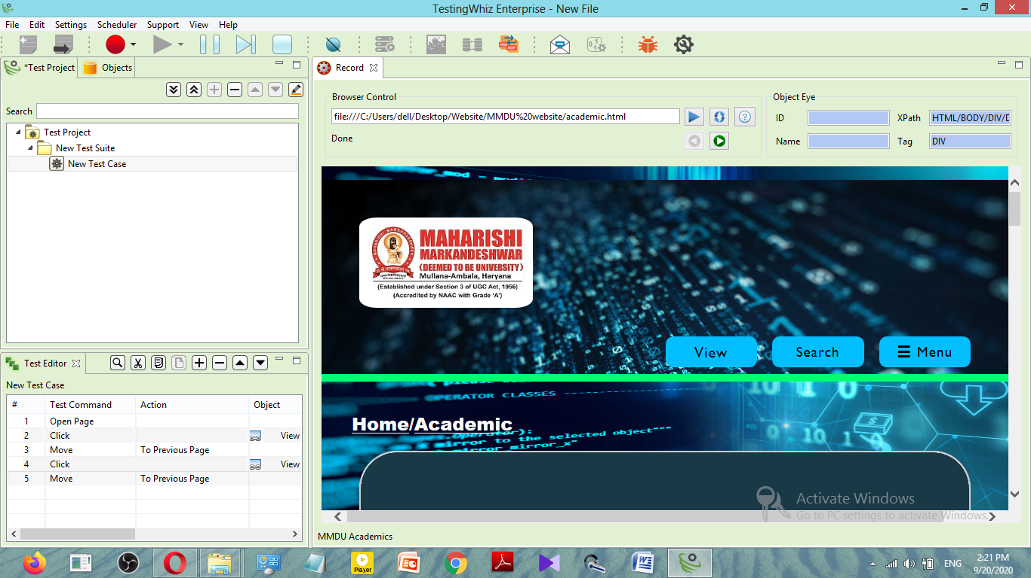

* **The View and Search button are not working**

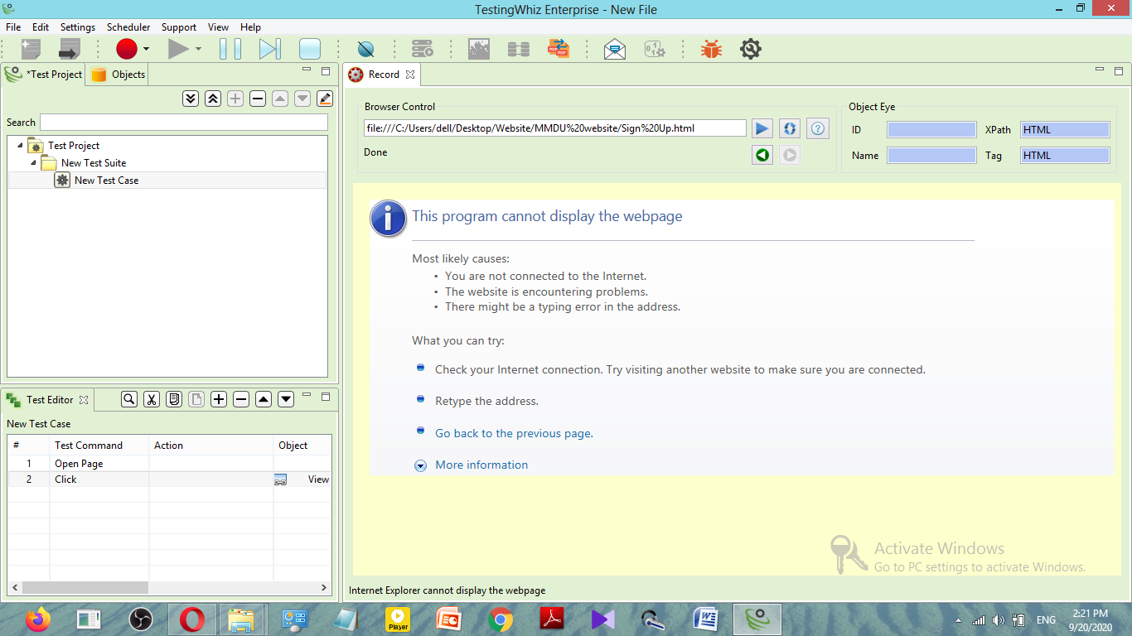

* **The Menu button is working properly but the About Us and Admission Webpage have not been created**

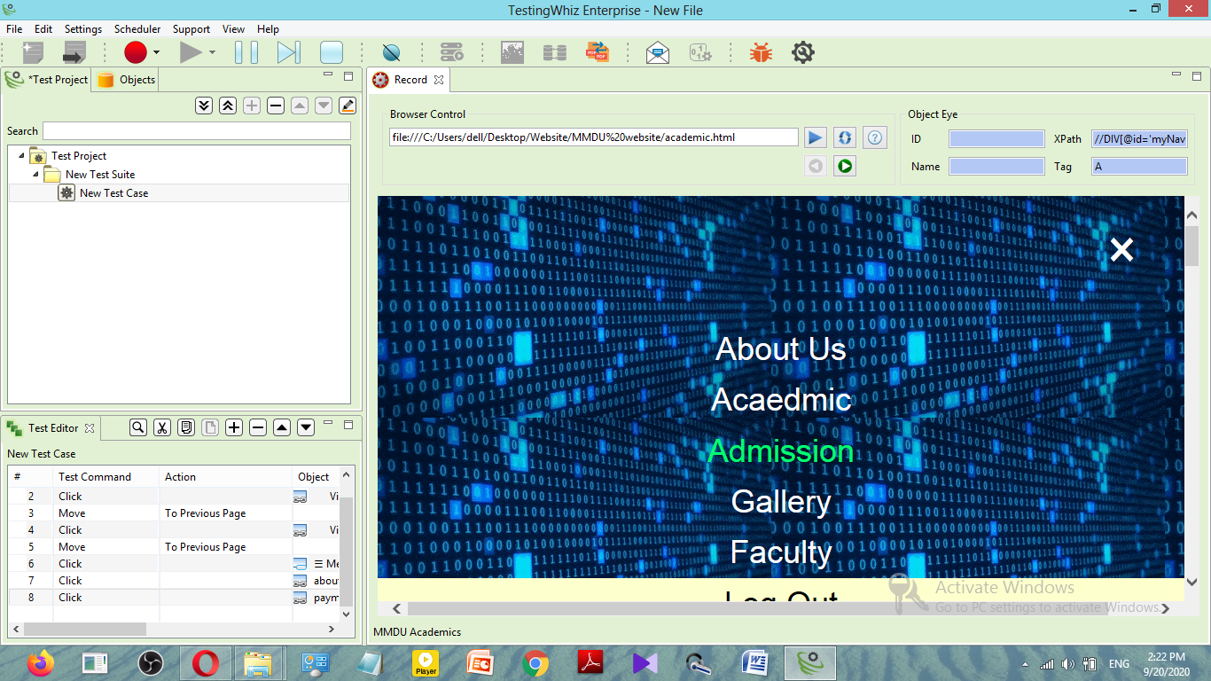

* **The faculty webpage has been created**



* **The Gallery Webpage is created.**

It has a slideshow of images of different events of SD along with the name of the event

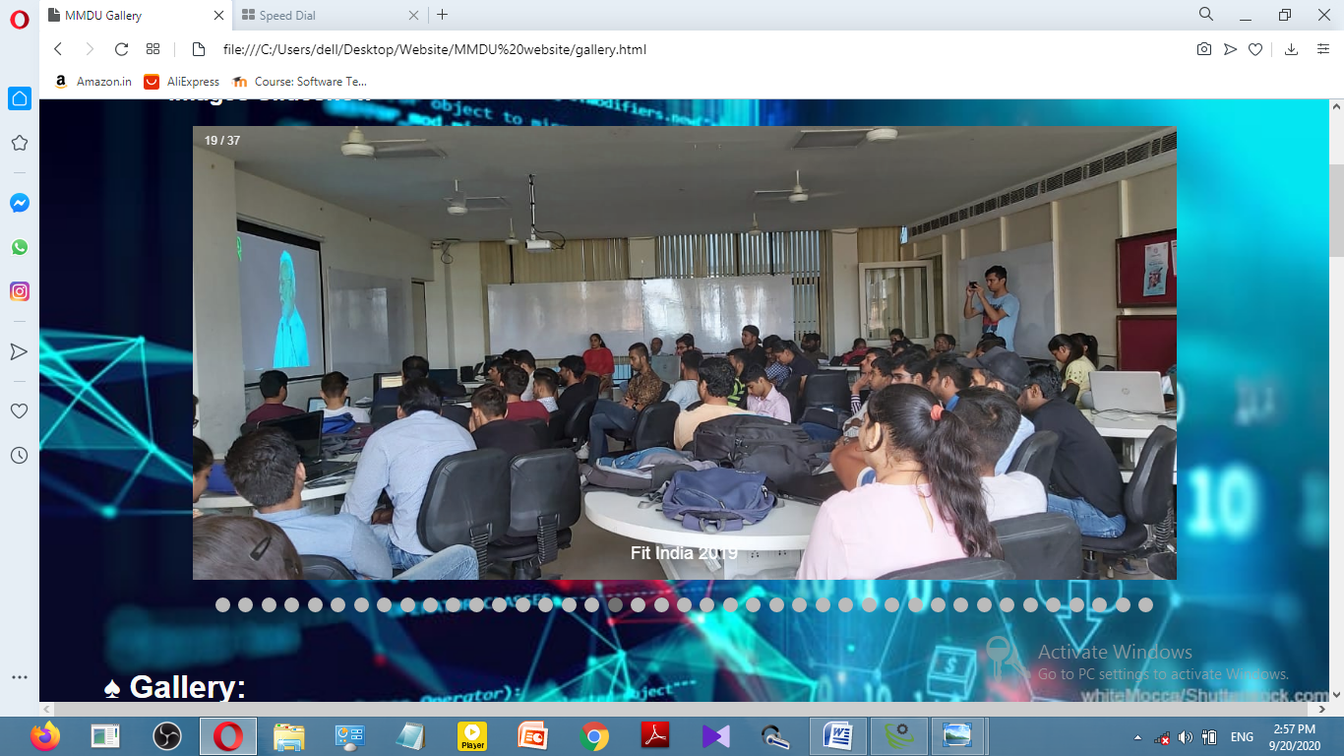

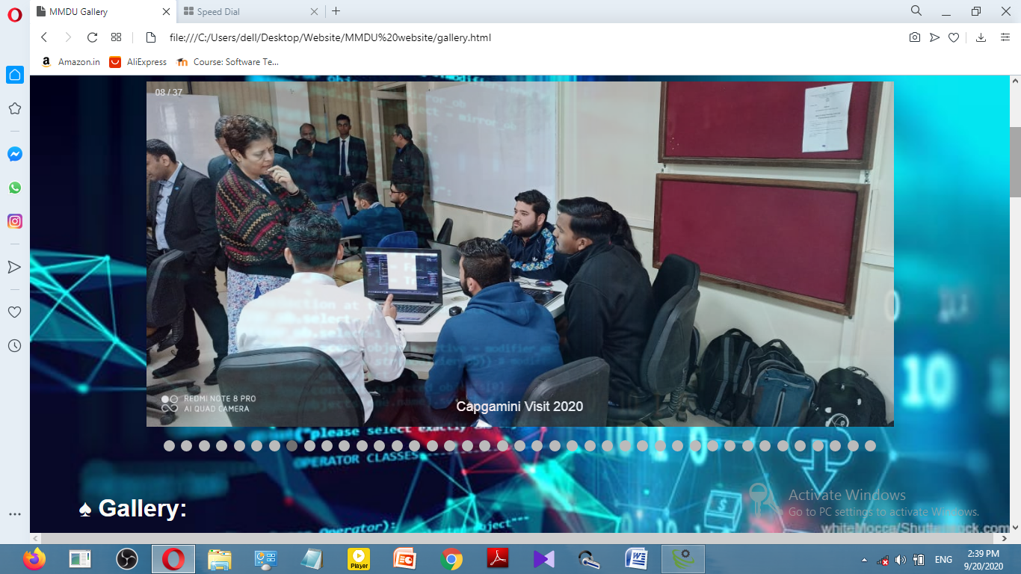

Webpages for viewing all photos of a particular events have also been created but there is no back button to go back from any event gallery page to the gallery page

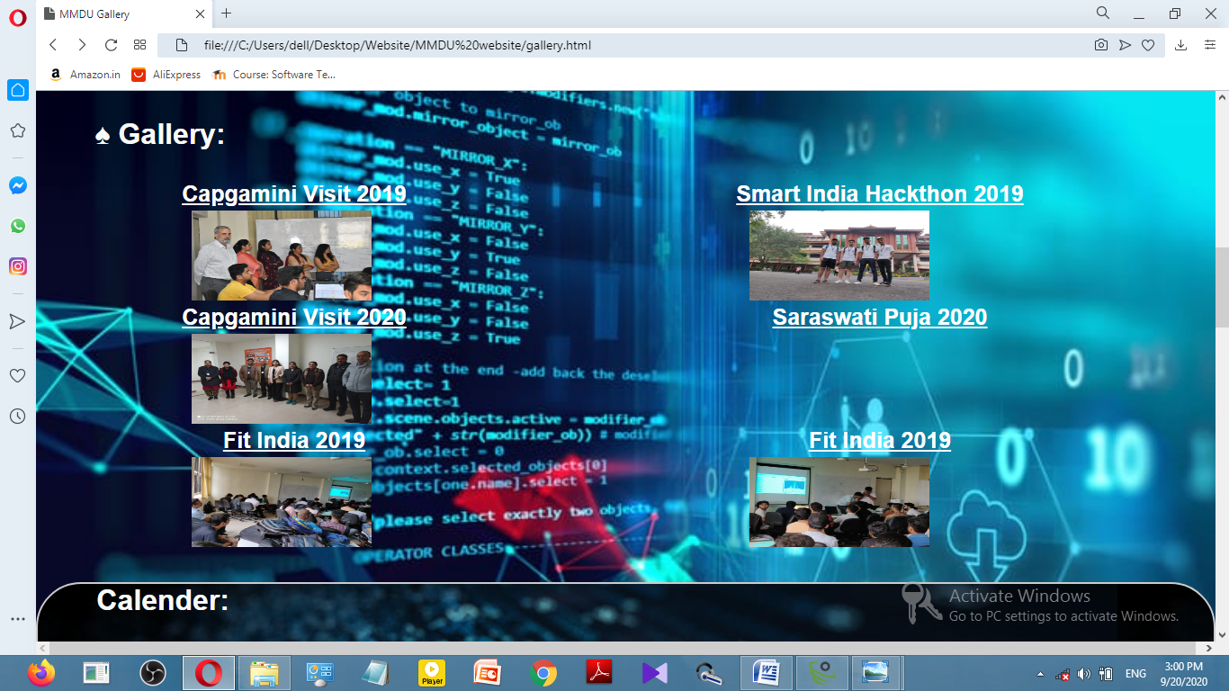

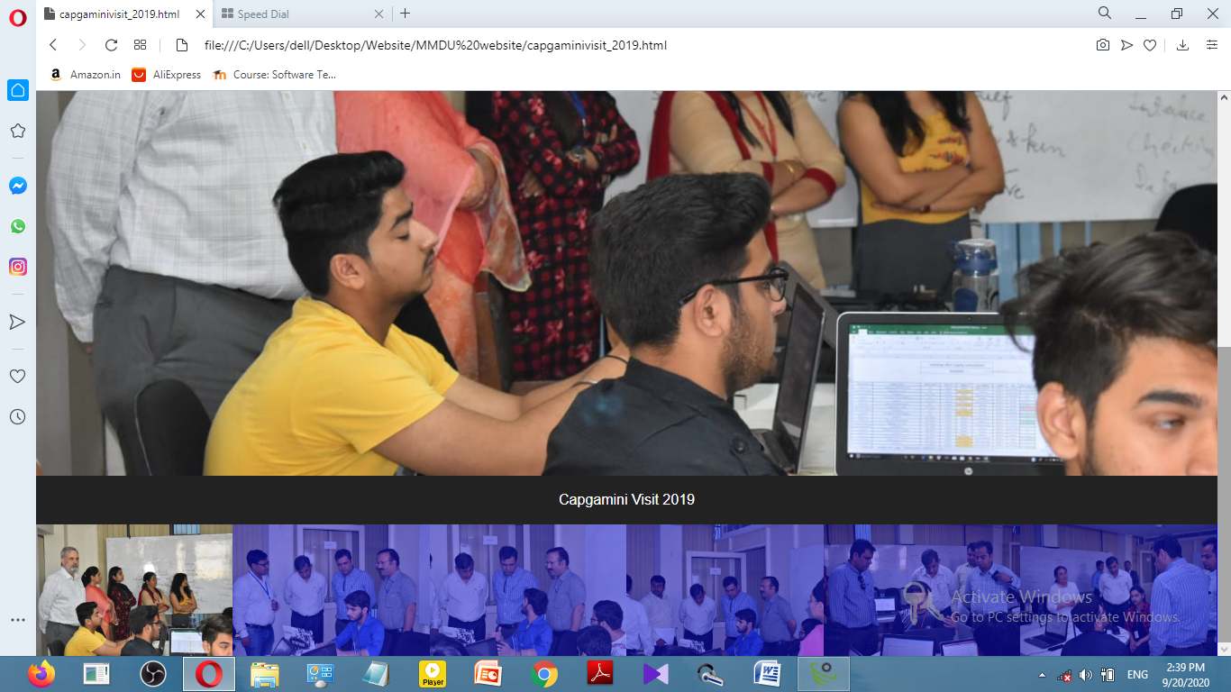

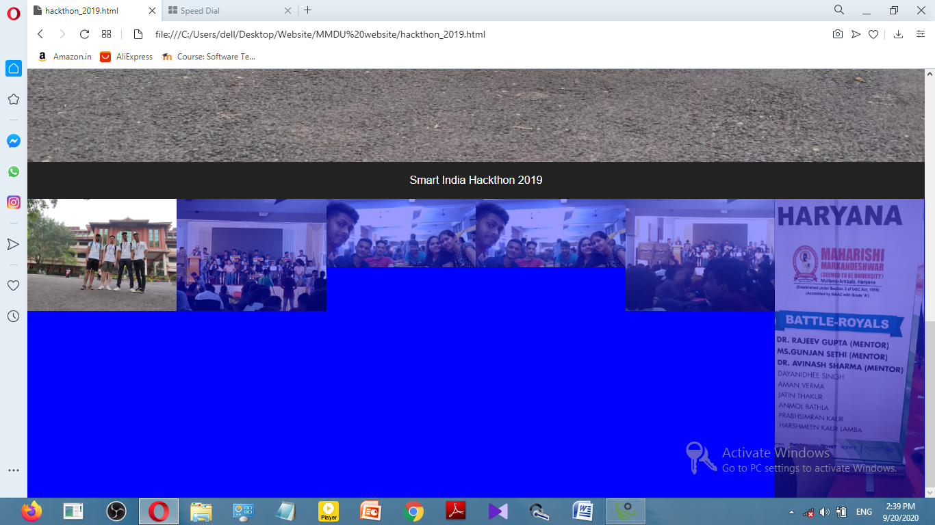

**A calendar has also been created in the gallery page**

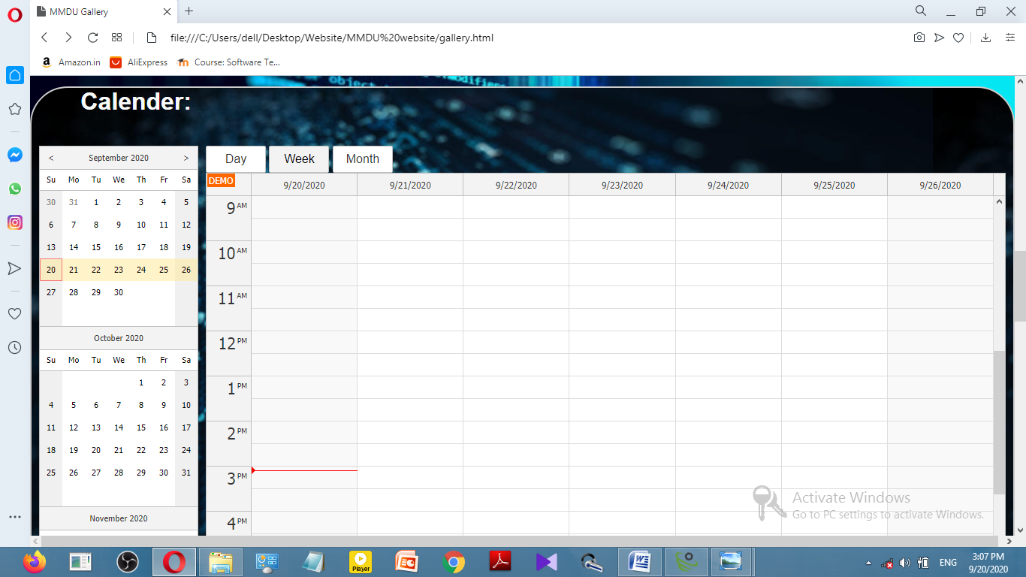

**An event list and form for requesting to host an event have been added in the gallery page.**

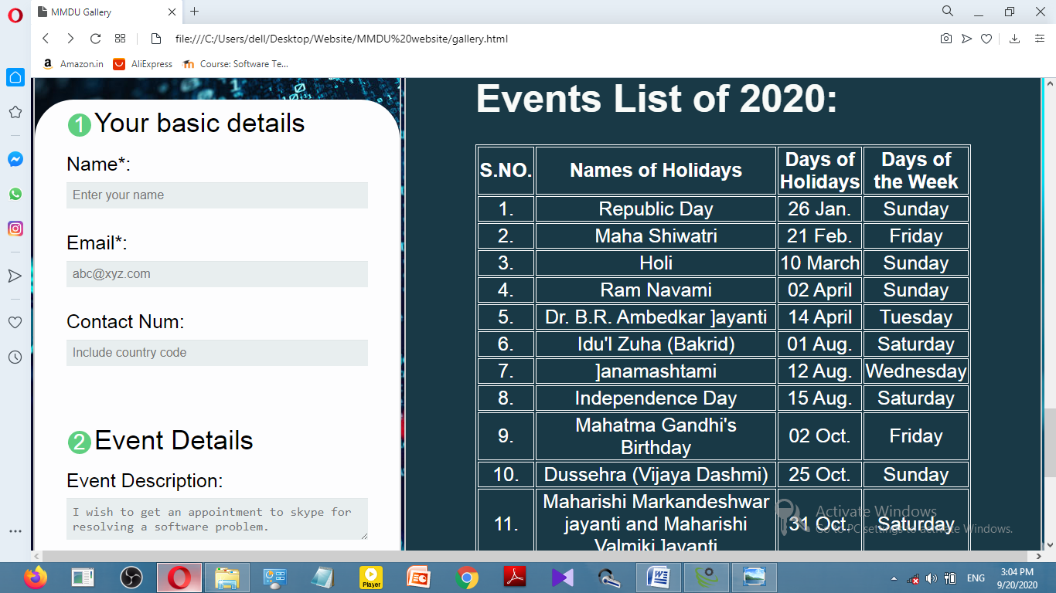

The form does not send the request to host the event if the email field, date field or time field are empty.

The name field has been set as a required field but it is possible to send the form without filling the name field

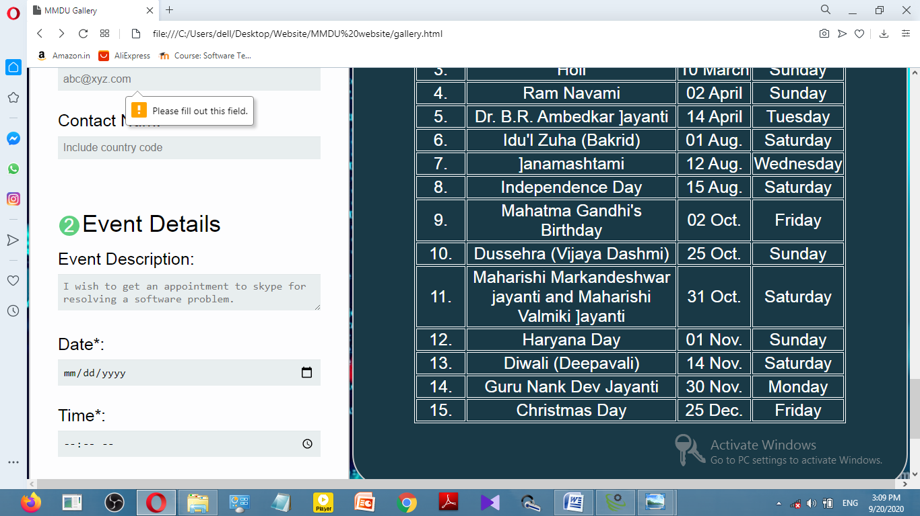

Once the fields have been filled, then the request for appointment button will work but since it uses PHP it is not working right now but the coding for PHP has been done

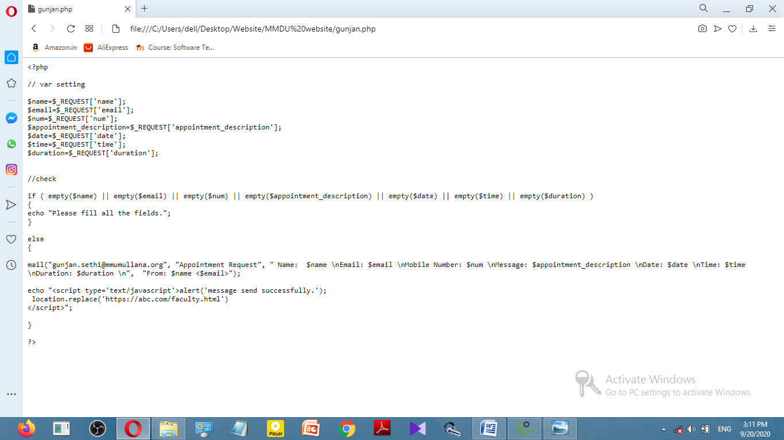

The FAQ button has also been added which sends the user to the FAQ webpage but the questions have not been added

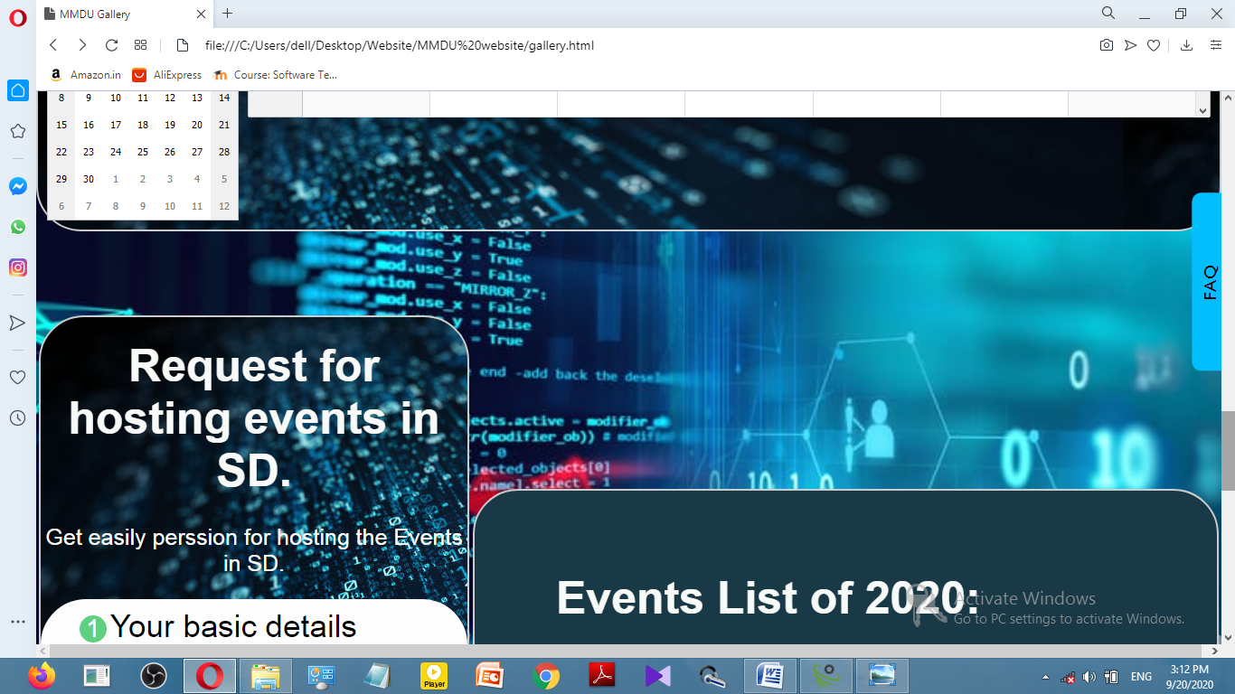

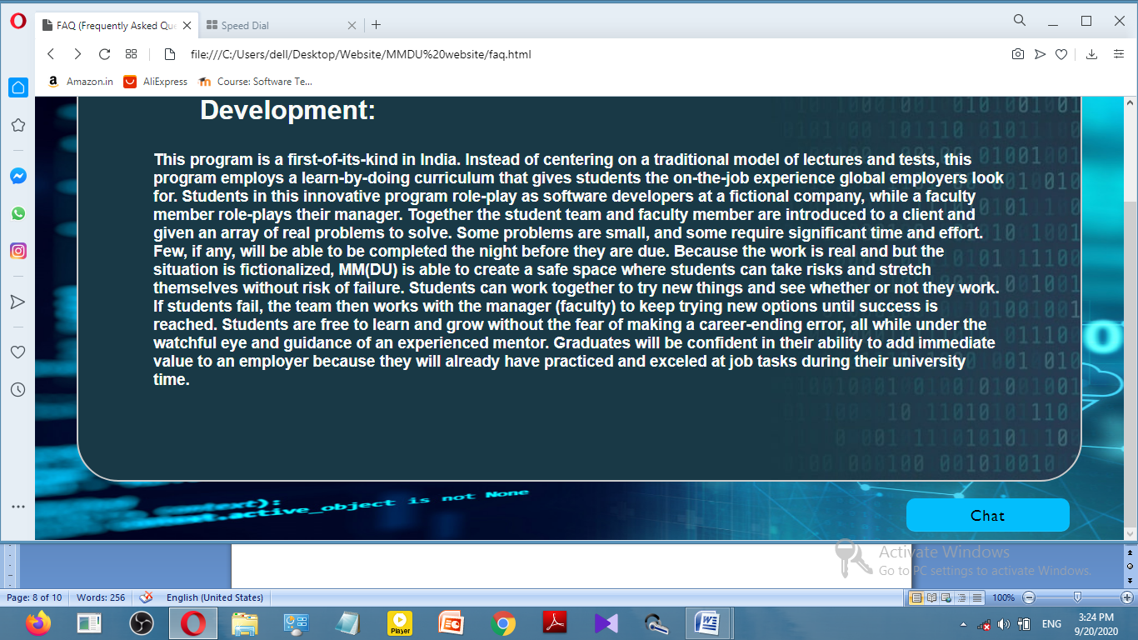

The FAQ webpage also has a button named chat for sending any message

The chat button will not send any message if the email and message field are not filled.

The name field has also been set as a required field but it is possible to send the form without filling the name field

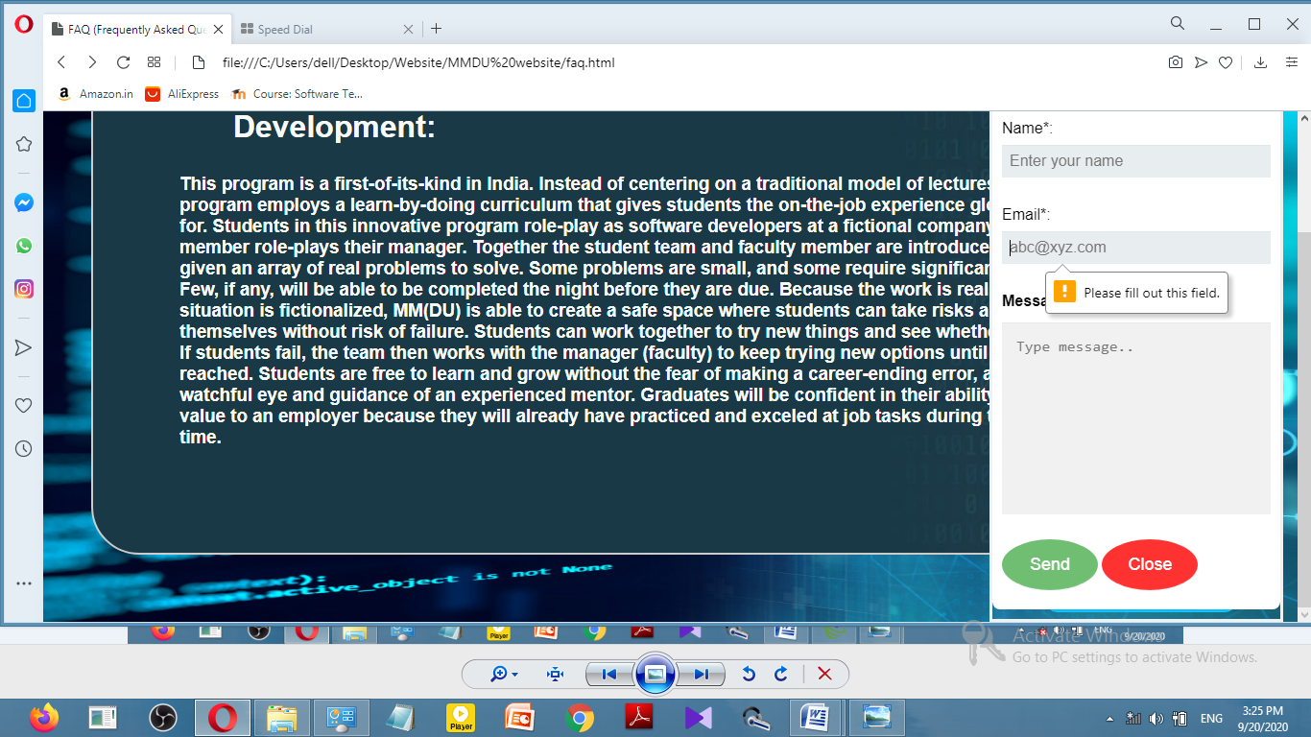

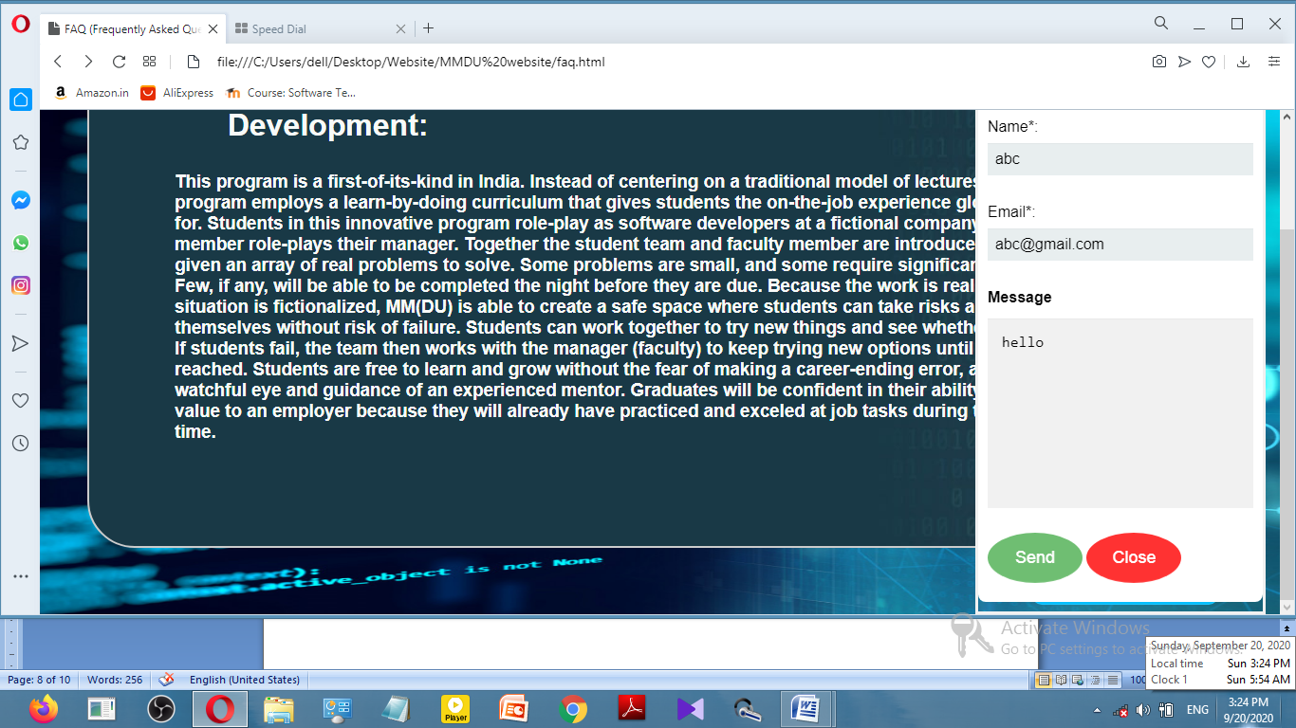

The message requires PHP to send but the coding for PHP has been done

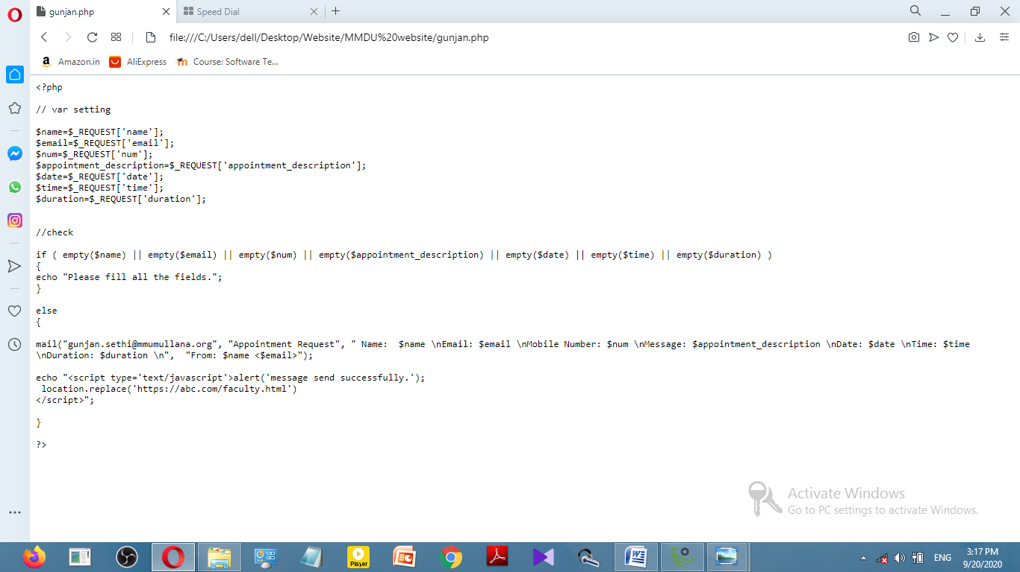

The user can logout from the menu.

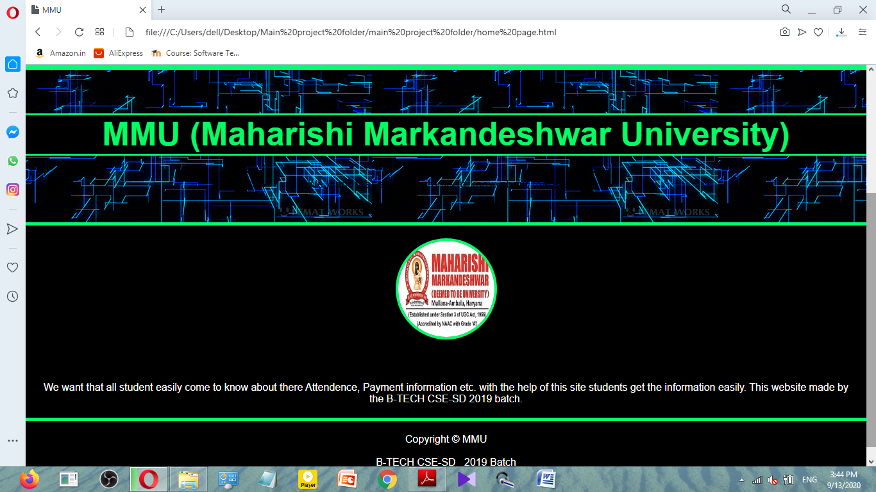

This is the report that was generated using Testing Whiz

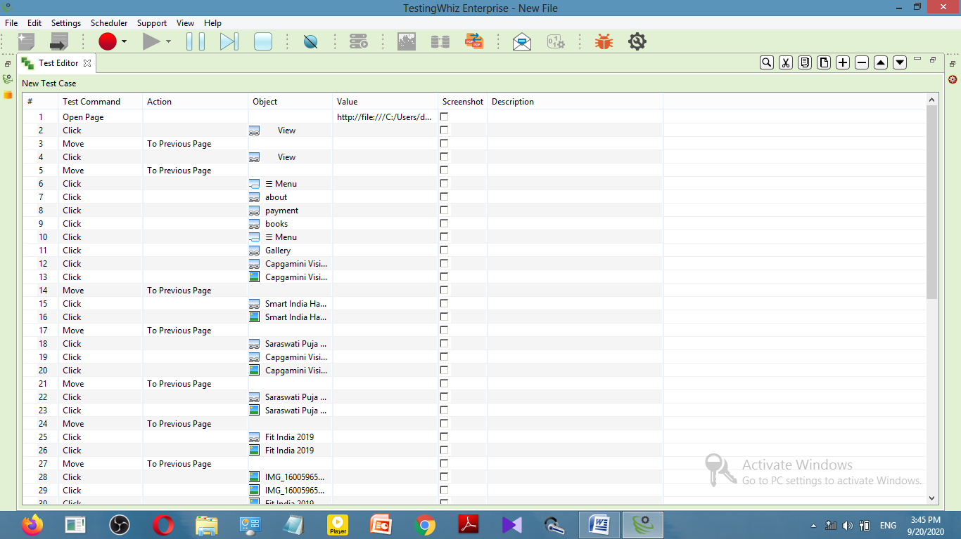

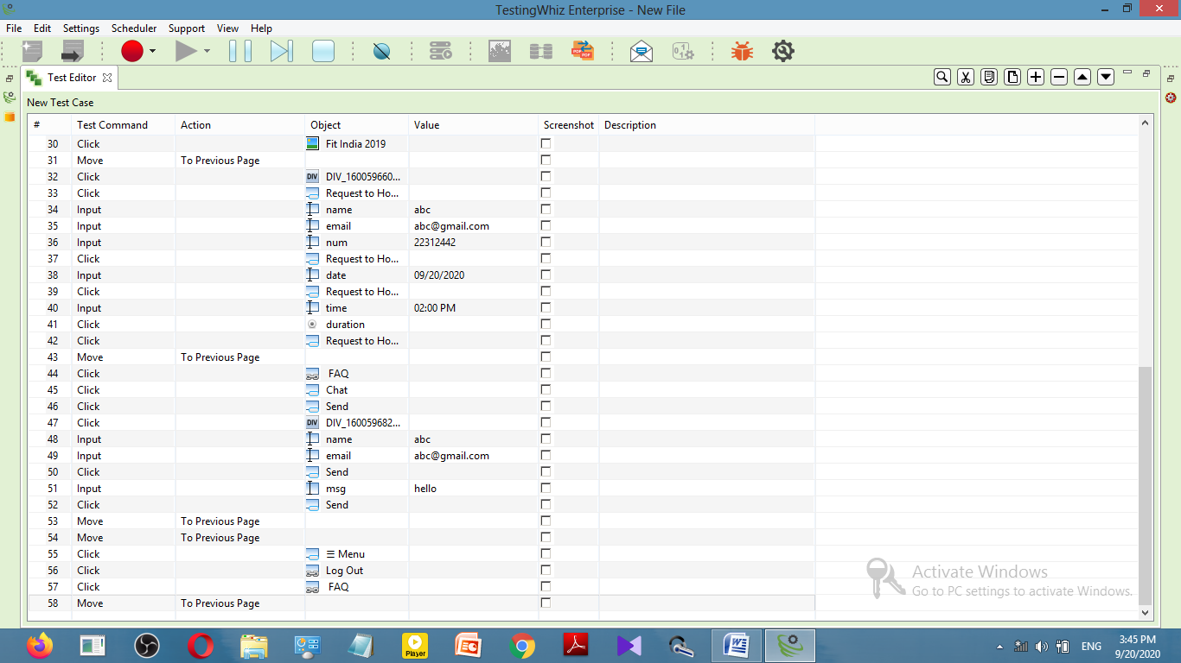

* **UI Requirements:**
* **Gallery Page:**

1. The 2nd layout background is not present in the images slideshow according UI.

**# UI**

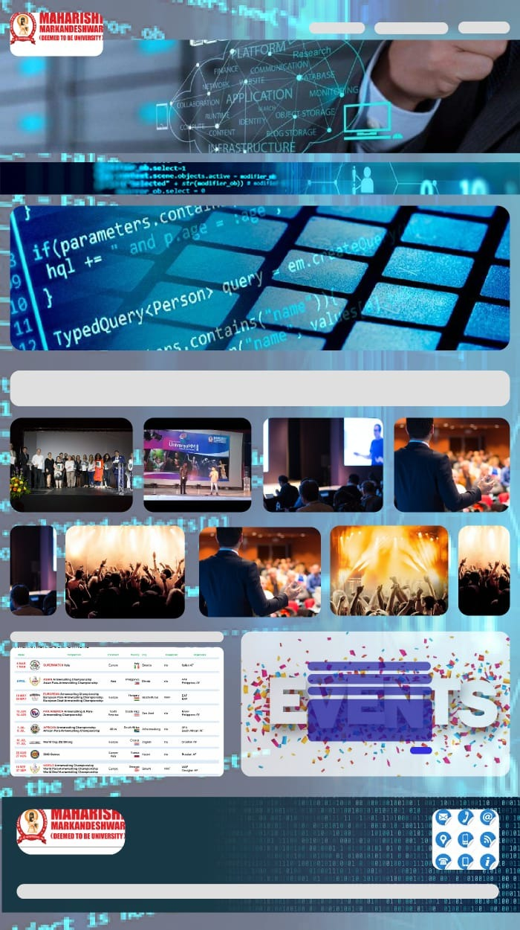

**# Website**

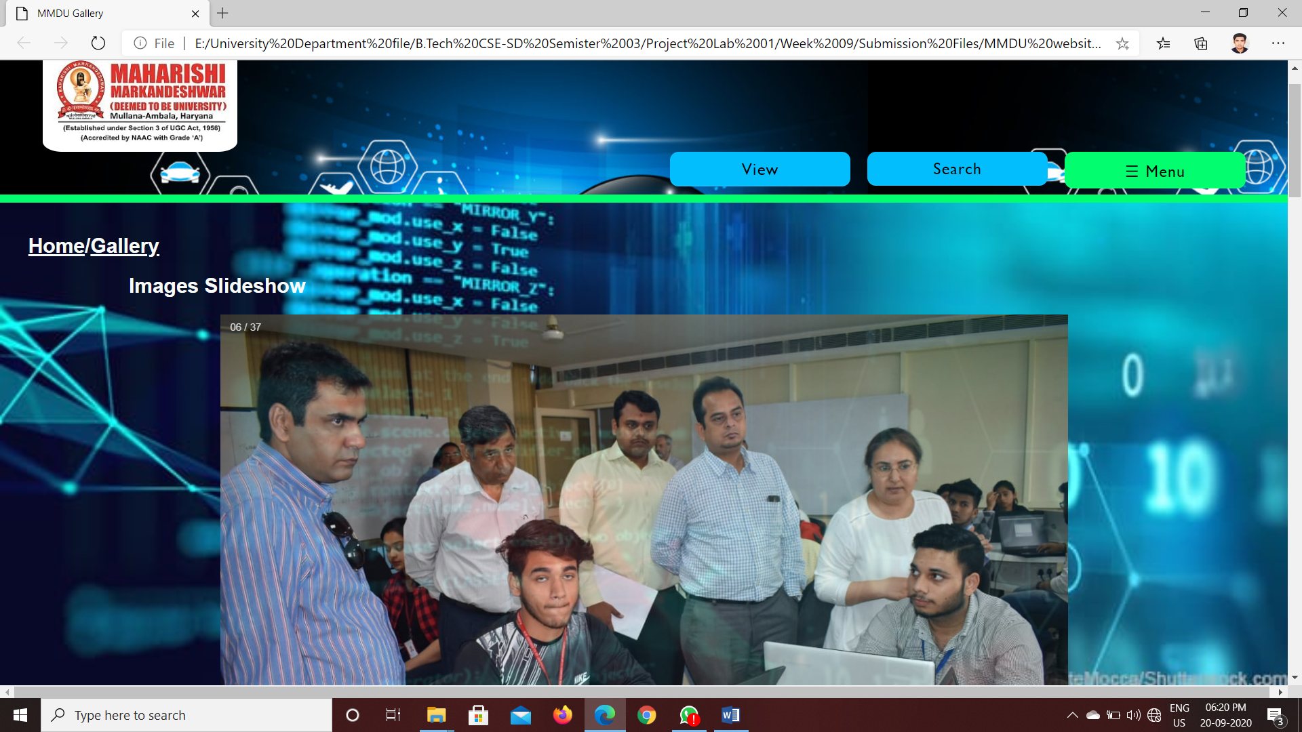

1. Gallery pattern is different than UI in Gallery page.

# UI



**# Website**

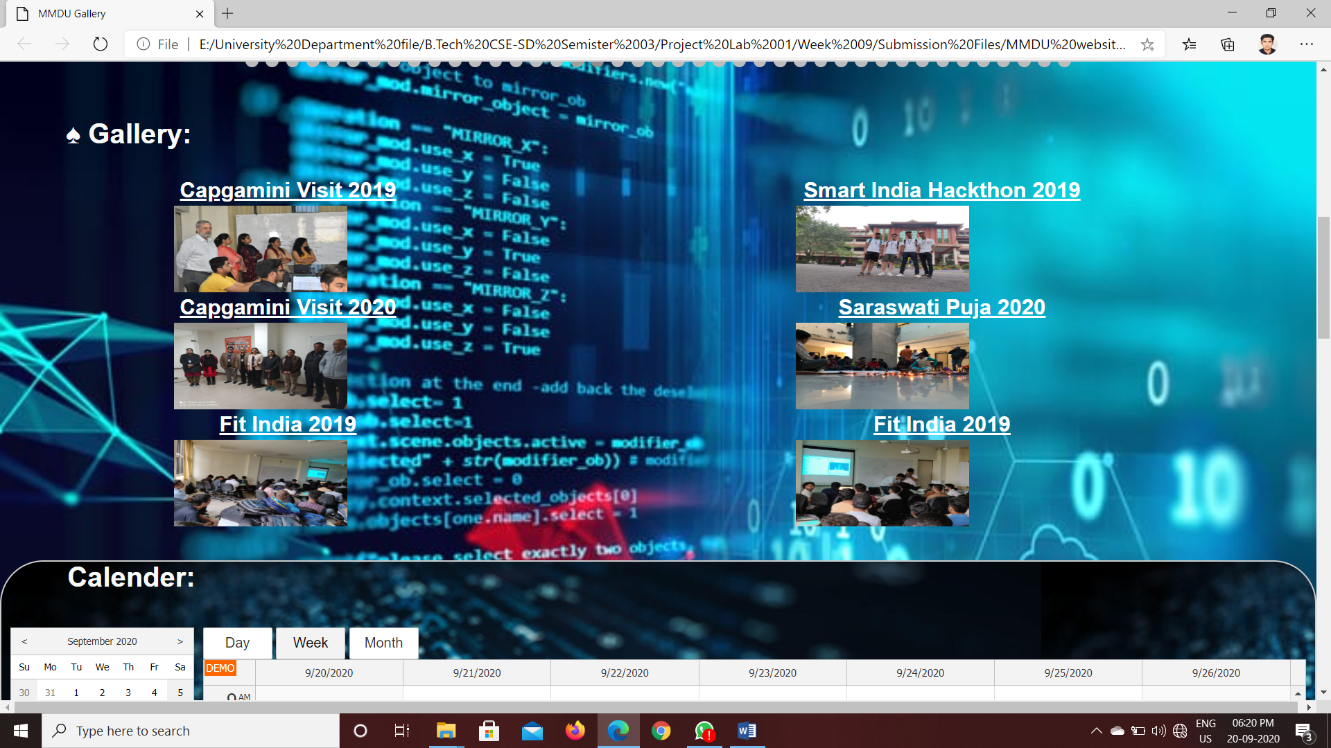

1. Calendar is too much large.

**# UI**



**# Website**

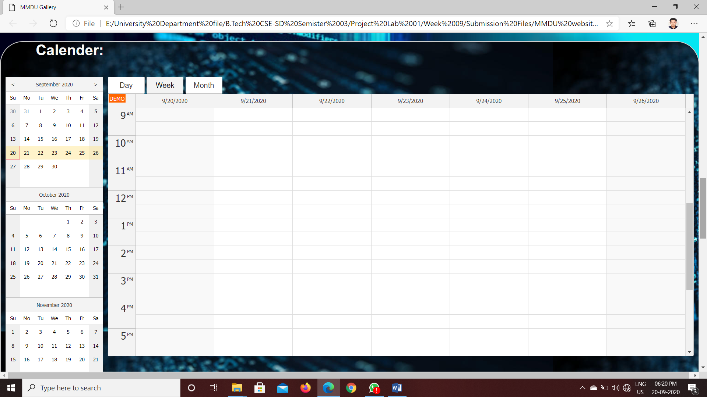

1. “Contact with us” option and “MMDU LOGO” is missing in the footer.

**# UI**



**# Website**

